

**KENYATTA UNIVERSITY**

**SCHOOL OF ENGINEERING AND TECHNOLOGY**

**DEPARTMENT OF COMPUTING, INFORMATION AND TECHNOLOGY**

**SCO 400: PROJECT PROPOSAL**

**NAME**: **HASSAN ABDISHAKOOR**

**REG. NO**: **J17/0796/2019**

**EMAIL**: hs1420163@gmail.com

**SUPERVISOR**: **MR. KENNEDY SIIKA**

**TITLE: ONLINE CUSTOMIZABLE FOOD ORDERING SYSTEM**.

**TABLE OF CONTENTS**

CHAPTER ONE 1

**1.0 INTRODUCTION** 1

**1.1 Background of the project** 1

**1.2 Problem Statement** 1

**1.3 Objectives** 1

**1.4 Scope and Limitation of Study** 2

**1.5 Justification** 2

CHAPTER TWO 3

**2.0 Literature Review** 3

**2.1 Introduction** 3

**2.2 Case study** 3

**2.3 Proposed System** 5

CHAPTER THREE 6

**Methodology** 6

**3.1 Design and Methodology** 6

**3.2 Research Methods** 8

**3.3 Data Collection Technique One-on-One Interviews** 8

**3.4 Development Tools** 8

**3.5 Tools for Testing** 8

**3.6Time Schedule and Project cost** 9

REFERENCES 10

# CHAPTER ONE

## 

## **1.0 INTRODUCTION**

### **1.1 Background of the project**

The concept of an online customizable food ordering system was developed in response to a rising trend among consumers who choose to eat healthier foods when dining out. In recent years, consumers have become more health-conscious, with an increasing focus on maintaining a healthy diet and lifestyle. This has increased consumer demand for calorie-appropriate menu options at restaurants, as well as for more transparency in the calorie content of food items. The project aims to address these needs by providing a user-friendly platform that allows customers to customize their food and drink orders to meet their dietary requirements and preferences. Additionally, the platform offers precise and simple-to-find calorie information for each menu item, which might aid customers in choosing what to eat. This project can benefit both customers and participating restaurants, as it can attract health-conscious customers and increase sales for restaurants, while also promoting healthier eating habits. In general, the initiative represents the growing need for technologically based solutions to address this trend as well as the demand for healthier food options.

### **1.2 Problem Statement**

The current food ordering system at restaurants fails to cater to the growing demand for transparent calorie information, leading to customer dissatisfaction and lost sales. The customers who are on a weight-loss journey will be disadvantaged and may not eat at restaurant with fear of breaking their diets. As well as the bodybuilders who require large amounts of calories to keep up with their heavy lifting sessions are most likely not eating in restaurants. Some customers who have allergies may not enjoy their favorite foods and drinks with fear of feeling unwell.

### **1.3 Objectives**

The objectives of the project are:

* To develop a registry module for users for them to get the services.
* To develop a system that will contain information of several restaurants with their menus.
* To design a system that will have a secure database that will be used to store data of users and their ordering status.
* To embed a review system allowing users to provide feedback for their experiences.
* To provide accurate and easily accessible calorie information for each menu item and for the users.

### **1.4 Scope and Limitation of Study**

The intention of this study is to develop a system that has its functionalities spans through the Eastleigh, Nairobi which involves the design and development of an online platform that offers optimum-calorie food and drinks options, order customization, and calorie tracking. It includes menu information and management, order processing, and customer support and feedback. However, the study is limited by the availability of accurate and up-to-date menu information, limited participation of restaurants, technical limitations, limited user adoption, regulatory compliance and challenge in calorie calculations.

### **1.5 Justification**

The proposed online customizable food ordering system is justified by its potential to address a range of important societal concerns. One such concern is the increasing demand for healthier food options and the need to promote healthy eating habits. The system will provide a convenient and platform for customers to browse menus, customize orders, and view calorie information, making it easier for them to make healthier choices. This will also benefit participating restaurants by increasing customer satisfaction and sales, and enabling continuous improvement based on customer feedback. Moreover, with the growing trend of consumers seeking more plant-based and low-carbon footprint food options, the project can offer an additional benefit by encouraging restaurants to include more plant-based options on their menus. By providing customers with the option to customize their orders with low-calorie, plant-based, and sustainable food options, the system can contribute to reducing the carbon footprint associated with the food industry, as well as promoting healthy eating habits. Thus, the project aligns with the growing interest in sustainable and environmentally-friendly practices and can contribute to a more sustainable future while addressing a significant public health issue.

# CHAPTER TWO

## **2.0 Literature Review**

### **2.1 Introduction**

Online ordering systems have become increasingly popular in the food industry. These systems allow customers to easily and quickly order food from their desired restaurants. In recent years, a new trend has emerged where customers can customize each food item on the menu, including the option to select low-calorie options. This review of literature aims to examine the existing studies on the online customizable ordering system and its implications for the food industry.

A study by Wang, Wu, and Li (2020) proposed a design for an online ordering system for restaurants. The system would provide customers with a platform to customize their orders, which would help them make healthier choices. Similarly, Dai, Hu, and Feng (2019) developed a personalized food ordering and nutrition tracking system, which allowed customers to track the nutritional value of their meals. By educating users on dietary options, this technology has the potential to improve consumers' health results.

Furthermore, Yuen, Lai, and Tse (2019) investigated the adoption and challenges of online food ordering systems by restaurants. They found that while the systems have benefits, such as increased sales and customer satisfaction, restaurants face challenges in implementing and maintaining them. Additionally, Demartini, Pau, and Massa (2018) conducted an empirical investigation into the factors influencing the use of online food ordering and delivery services in Italy. They discovered that the choice to use these systems is influenced by elements including convenience, trust, and quality.

In conclusion, the research indicates that businesses and customers may both profit from online configurable ordering systems. The systems can help customers achieve better health outcomes by letting them choose healthful foods. Additionally, restaurants might gain from higher sales and happier patrons. However, restaurants may face difficulties with the installation and upkeep of these devices. This evaluation emphasizes the need for additional investigation into the merits and difficulties of online configurable ordering systems.

There are number of web systems that are in place for ordering food and giving calorie information at a go. The one under our study will be Nutritics.

### **2.2 Case study**

Nutritics is a comprehensive ordering system allows foodservice operators to manage click & collect, delivery and ordering (both in-house and in-queue) from one centralized platform. Nutritics deliver a seamless ordering experience across multiple locations. It also gives detailed allergen, calorie, nutrition and pricing information available and automatic updates as soon as your recipes or menu change.

**Advantage of the web system:**

1. Simple for customer to navigate and order food and drinks.
2. Automatically updates customers menu changes for future references.
3. Gives full calorie information of foods and drinks.

**Disadvantages:**

1. Customers cannot substitute ingredients to their preferences.
2. Times for ordering some foods is limited.
3. Constant updating of menus may make customers confused as their previous selections may be lost.

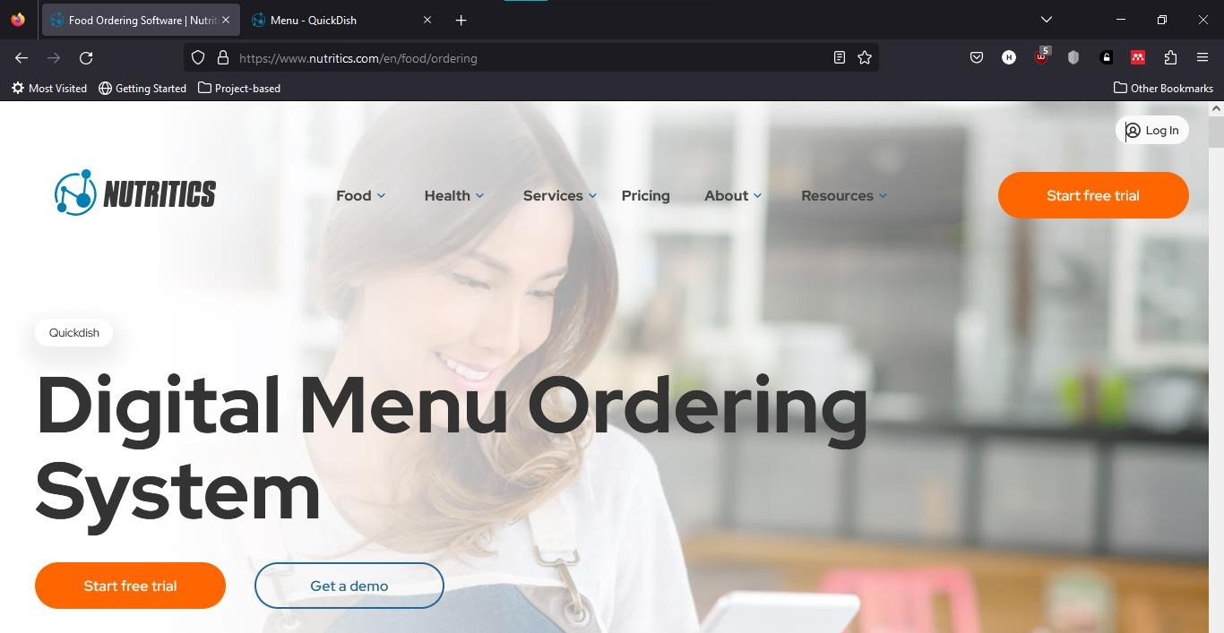

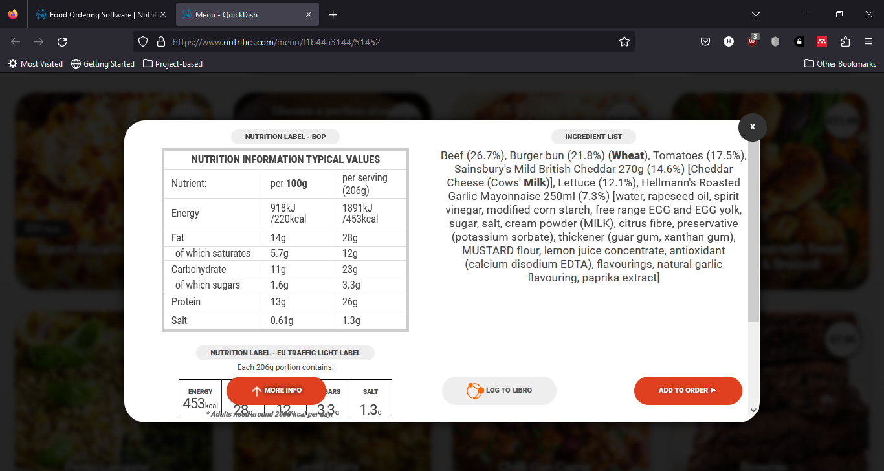

### **2.3 Proposed System**

Build a web system that a user logs in whenever there is internet connectivity that does the following:

* Allow customers to add and remove particular ingredients from their food orders to suit their dietary needs and preferences.
* Describe the nutritional value of each item on the menu so that customers can make educated decisions.
* Allow clients to save their personalized orders for later use.
* Eliminate the need for phone call or in-person orders to streamline the ordering process.
* Allow online order tracking and payment.
* Give information about well-liked menu items, client preferences, and order history to restaurant owners so they may make business decisions

# CHAPTER THREE

## **3.0 Methodology**

### **3.1 Design and Methodology**

The approach or methodology to implement certain projects are numerous. Thus, some of these methodologies include:

**Waterfall Methodology**

The ancestor of all life cycle models. Each successive module in the system depends on the previous module being completed.

Stages of the project flows from the top to the bottom without going back to a finished stage. It involves sequence completing one task before moving on to the next, all the way to project completion. The goals and timelines are clearly defined for project delivery.

It follows a sequence of steps:

●Planning

●Analysis

●Design

●Development or Implementation

●Testing

●Deployment & Maintenance

**Merits of Waterfall Approach**

•Requirements are identified long before programming begins

•Changes to the requirements as the project proceeds are limited.

**Demerits of Waterfall Approach**

* The design must be completely specified before programming begins.
* Time between system proposal completion (analysis phase), and system delivery is too long.
* Testing is treated almost as an afterthought in the implementation phase.

**Agile-Scrum Software Model**

Agile software methodology is an iterative approach that builds software incrementally from the start of the project rather than delivering it once. Agile models allow the use of increments or possible prototypes that can evolve into a more suited and validated requirements and eventually software application.

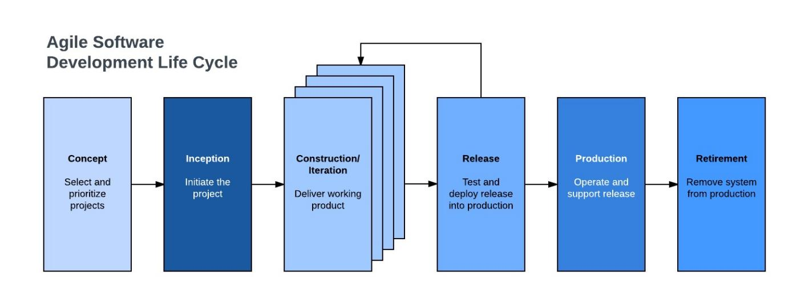

**SCRUM Process Model**

It is an agile process model which follows these activities: requirements, analysis, design, evaluation and delivery. Scrum emphasizes the use of a set of software process patterns that have been proven effective for projects with tight timelines, changing requirements and business criticality.

Why use agile for our project?

We will use Agile-Scrum as our methodological approach because it is:

* It is designed to curate the needs of rapidly changing environment by embracing the idea of incremental development and developing the actual final product.
* It requires constant comments from the user thus gives priority to the people than the process.
* Deployment and delivery are quicker thus gaining user confidence.

### **3.2 Research Methods**

We will use both the qualitative and quantitative research method since we will be aiming to get know more about gap between the customers, restaurants and their respective information needed.

### **3.3 Data Collection Techniques**

We will use one-on-one interviews, questionnaires and observation with the users around me that are willing to eat at restaurants and restaurants that are currently open and inquire what they would like a ordering system to have. Also ask if they have encountered any inconvenience in a ordering they made previously due to lack of prior information and lack of choosing sites.

### **3.4 Development Tools**

|  |  |
| --- | --- |
| Programming languages | HTML, CSS, JAVASCRIPT AND PYTHON |
| DBMS | MySQL Workbench |
| FRAMEWORK | Django |
| SERVER | Django built-in Server |

### **3.5 Tools for Testing**

1.Firefox: for debugging and testing web applications.

2. Django Testing Framework: Provides tools for writing unit tests and integration tests for Django applications.

3.Google Chrome: We will to test our JavaScript scripts.

### **3.6Time Schedule and Project cost**

**Project time span**

|  |  |  |  |  |  |  |  |  |  |  |  |  |  |  |  |
| --- | --- | --- | --- | --- | --- | --- | --- | --- | --- | --- | --- | --- | --- | --- | --- |
| **Activity** | **Time (weeks)** | | | |  |  |  |  |  |  |  |  |  |  | |
|  | **1** | **2** | **3** | **4** | **5** | **6** | **7** | **8** | **9** | **10** | **11** | **12** | **13** | **14** | |
| Drafting concept paper |  |  |  |  |  |  |  |  |  |  |  |  |  |  | |
| Planning |  |  |  |  |  |  |  |  |  |  |  |  |  |  | |
| Analysis |  |  |  |  |  |  |  |  |  |  |  |  |  |  | |
| Proposal writing |  |  |  |  |  |  |  |  |  |  |  |  |  |  | |
| Design |  |  |  |  |  |  |  |  |  |  |  |  |  |  | |
| Coding |  |  |  |  |  |  |  |  |  |  |  |  |  |  | |
| Testing |  |  |  |  |  |  |  |  |  |  |  |  |  |  | |
| Deployment |  |  |  |  |  |  |  |  |  |  |  |  |  |  | |
| Documentation |  | | | |  |  |  |  |  |  |  |  |  |  | |
|  |  | | | |  |  |  |  |  |  |  |  |  |  |  |

**Cost estimates**

|  |  |
| --- | --- |
| **ITEM** | **COST(KSHS)** |
| HP 820 G3 8GB RAM | 29,000 |
| Internet Services | 4500 |
| Printing Services | 1,700 |
| Miscellaneous | 3,300 |
| **TOTAL** | 38500 |

# REFERENCES

1. Dai, H., Hu, X., & Feng, J. (2019). Personalized food ordering and nutrition tracking system. In 2019 14th International Conference on Computer Science & Education (ICCSE) (pp. 428-433). IEEE.
2. Demartini, C., Pau, L. F., & Massa, S. (2018). An empirical investigation of the factors influencing the use of online food ordering and delivery services in Italy. Journal of Retailing and Consumer Services, 41, 242-248.
3. Wang, H., Wu, H. Y., & Li, H. (2020). Design of an Online Food Ordering System for Restaurants. In 2020 2nd International Conference on Computer Science and Technologies in Education (CSTE) (pp. 438-443). IEEE.
4. Yuen, C. W., Lai, V. S., & Tse, E. Y. (2019). Online food ordering system: The adoption and challenges of restaurants. International Journal of Hospitality Management, 78, 128140.